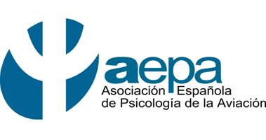
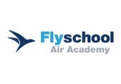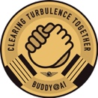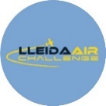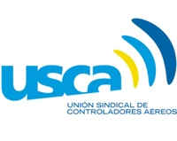

XVI AEPA Conference

SPANISH ASSOCIATION OF AVIATION PSYCHOLOGY

360º Human Factors:

AI, Assessment and Training under the radar of Aeronautical Psychology

Date: Friday, September 26, 2025.

Hours: from 9:30 a.m. to 2 p.m.

Place: General Council of Psychology of Spain

C/ Conde de Peñalver, 45. 3rd floor. 28006 Madrid

09.30-10.00 | Opening of the Conference  Adela González Marín. President of AEPA  AESA Representative
10.00-11.00 | The future of air traffic control. Automation and Artificial Intelligence?  María José Valdés Calvo  USCA Secretariat and Air Traffic Controller
11.00-11.30 | Coffee break
11.30-12.30 | Psychology in instruction, evaluation and inspection of pilots and aeronautical training centers  Javier Santiago García Sanz  Expert technician in pilot training organizations. SENASA
12.30-13.30 | Beyond the ideal profile: current challenges in the psychological evaluation of air traffic controllers.  María Aránzazu Hernández Rodríguez.  People Director. ENAIRE  Herminia Ruiz Galán.  Head of the Department of Selection, Evaluation and Development of People. ENAIRE
13.30-14.00 | Questions/Discussion
POSTERS | Mental Health Promotion & Peer Support by Air India  (Based on the same required formal rules as in Europe) Alois Farthofer.  Clinical and Aviation Psychologist  The role of civil society in improving aeronautical safety and training: experience of the TOMI Foundation  Luz María Ramírez Chamorro  President and Founder of the TOMI Foundation

Register here: https://docs.google.com/forms/d/e/1FAIpQLSdBcZOpLZ4JLQC4KAJyyJRTKu63OsmaKvjJjH5Jz_2R0XKgZg/viewform

